Game Design Document

Fill up the Following document

1. Write the title of your project.

Ludo for 2-6 players

1. What is the goal of the game?

To move all four of the player's pieces clockwise once around the board, up the home column, and into the home triangle.

1. Write a brief story of your game?

Each player will get turns to roll the dice, and according to the number they get in the dice, they will be able to move their pawns/token. If two player’s token land on the same spot, the player who landed first is returned to its owner’s yard. Likewise, all players try to return other people’s token to its yard, so that it becomes easier for them to enter into the home triangle. The player whose entire token enter the home triangle wins.

1. Which are the playing characters of this game?

* Playing characters are the ones which respond to the user based on the input from the user
* Cars, monkeys, dinos, wizards etc, are the playing characters in the game.

|  |  |  |
| --- | --- | --- |
| Number | Character Name | What can this character do? |
| 1 | Player1 | Can spin the dice and decide which token to move |
| 2 | Player2 | Can spin the dice and decide which token to move |
| 3 | Player3 | Can spin the dice and decide which token to move |
| 4 | Player4 | Can spin the dice and decide which token to move |
| 5 | Player5 | Can spin the dice and decide which token to move |
| 6 | Player6 | Can spin the dice and decide which token to move |
| 7 |  |  |
| 8 |  |  |

1. Which are the Non Playing Characters of this game?

* Non Playing characters are the ones which don't have an action or a behaviour when the user interacts with the game.
* Hurdles, stones, bananas, coins, etc are non playing characters in the game.

|  |  |  |
| --- | --- | --- |
| Number | Character Name | What can this character do? |
| 1 | dice | Show numbers when mouse is pressed on it |
| 2 |  |  |
| 3 |  |  |
| 4 |  |  |
| 5 |  |  |
| 6 |  |  |
| 7 |  |  |
| 8 |  |  |

Draw your imagination of this game. What does this game look like?

* Draw the game either on your computer or on paper,
* Add images of scenes of the game to show each of the playing and non-playing characters at least once.

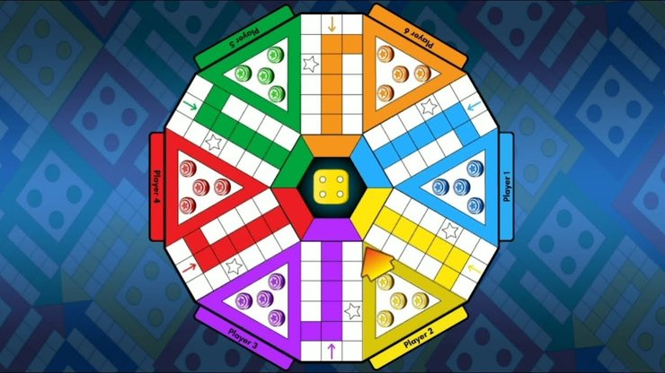

How do you plan to make your game engaging?

Add animation when a player is returned to its yard or when a player enters the home triangle. Also use sound effects to make the game engaging.